CASE STUDY -1 (low level application)

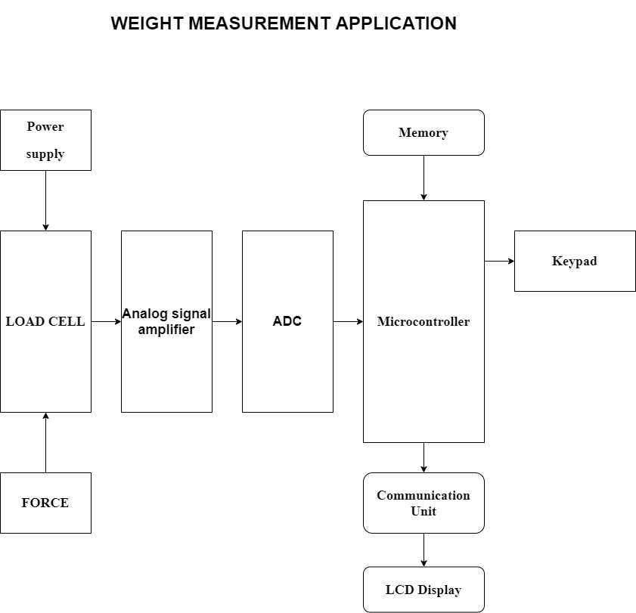

BLOCK- DAIGRAM

EXPLANATION:

1. Load Cell →

* It is essentially force sensor or force transducer.
* It is used principally to measure weight.
* It converts a load or force acting on it into an electronic signal.
* When load, force or stress is applied to the sensor. It changes its resistance.
* This change in resistance leads to a change in output voltage when a input voltage is applied.

1. Signal Amplifier→

* Load cell output signal is very weak.
* So it’s required for this signal to amplified up to convertible range to convert analog to digital signal.

1. ADC→

* Microcontroller can’t understand analog signal directly so use ADC.
* Amplified signal filter to avoiding damping signals for constant and accurate reading.
* Analog to digital converter resolution define final scale resolution, so ADC resolution must be high.

1. Microcontroller→

* Digital signal received by microcontroller and process it after processing signal it’s provide final output of weight in digital display.

1. Display & Memory→

* LCD display received signal by microcontroller and process it after processing signal it’s provide final output of weight in LCD display.
* This is a nonvolatile memory that is often used to store system configuration parameters for an microcontroller application.

1. Power supply→

* Power supply unit provide to all section of main control unit of microcontroller, display unit, amplifier and ADC.
* Power supply unit is very important just like food for all electronics circuit.
* If power is best filtered and regulated then working more effectively and life of circuits is improve.